Bull City Inflatables
Fundraising
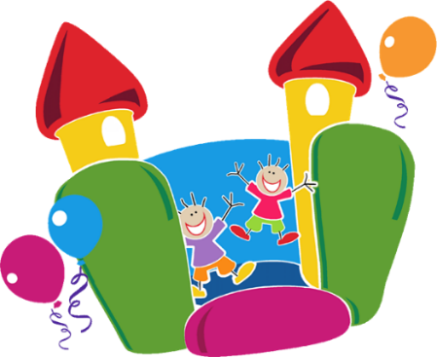
No Costs at all for your Organization!
It’s an Easy and Fun way to gain Funds!
We Supply the Inflatables to your Site.
We Set up and Break down Everything.
We staff the Event.
Use our Flyer which can be Edited, to send to your Groups.
We provide the Wristbands to Sell for Your Fundraiser.
$5 per wristbands - $2 goes towards your Fundraiser!
Sample Sales for 100 kids = $200 towards Fundraiser!!
Fundraisers Must take place Mon-Fri 8a-5p for 1-3 hours
Make the Money you need for your Organization at No Cost!
Required
- On Site place for Inflatables
- 30 Wristband Sales a Minimum is Required
- Book 7 days in Advance
Call Today to Book your Event 919-627-7132!!

